INFO7374 - Team 6

Assignment 3 - Part 1

**1. How is sales related to week numbers?**

**2. How does TV spending affect sales? Can you quantify it?**

**3. Are there any adstock effects for TV ad spending?**

**4. How does Radio spending affect sales? Can you quantify it?**

**5. Are there any adstock effects for radio ad spending?**

# 1. How is sales related to week numbers?

According to the graph plotted , we have considered base sales + tv_sales + radio_sales against week. The base sales increase as the weeks pass as well as the tv_sales & radio_sales but at one point the sales get stagnant and see a declining effect in sales. This could be due to the fact that when the adstock reaches its saturation , the customers aren’t interested in buying the product anymore.In statistics, it means it won't have a similar linear effect as it was during initial days when ad campaign launched.

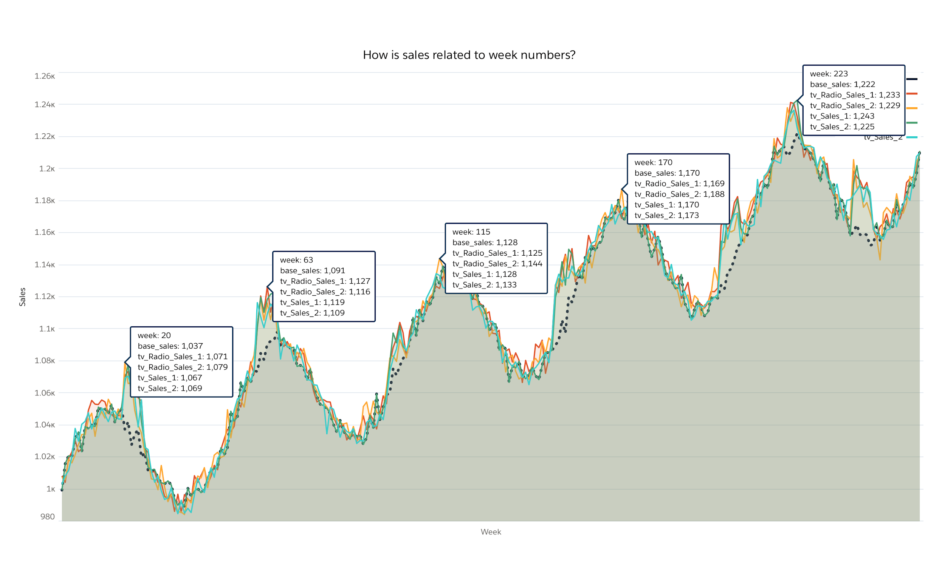

# 2. How does TV spending affect sales? Can you quantify it?

# AND

# 3. Are there any adstock effects for TV ad spending?

According to the graph plotted, an increase in the tv_spend does not increase the tv_sales immediately for both tv_sales_1 & tv_sales_2. The increase in tv_spend would increase awareness to a new level and there is a high chance that customers would purchase the product of this brand. If the customer would not have seen the advertisement again after the first time, they would not be able to recall the brand easily. Hence the tv_sales increases in due course of time.

Adstock effect is seen immediately when spending began on TV ads. Also, TV Ad spends are remembered longer than radio ads

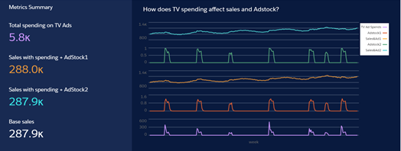

Below is a detailed graph of when the Ad spends were done for the first time on TV

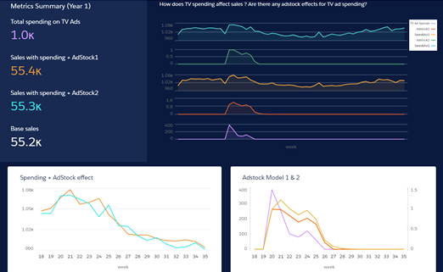

We have attempted to quantify it in the table below as asked in question 2 ie effect of TV ad spends on sales:

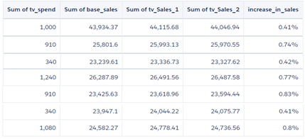

# 4. How does Radio spending affect sales? Can you quantify it?

# AND

# 5. Are there any adstock effects for radio ad spending?

According to the graphs, we have plotted even though Marketa spent on radio ads the effect on sales was not immediate. We noticed the Decay effect of adstock after the spends were made on radio ads

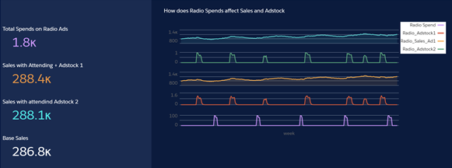

Below is a detailed graph of when the Ad spends were done for the first time on radio



 